Spy USB Stick
User Manual

Package Contents
- Spy Black and Silver USB Stick
- USB Extension Cable
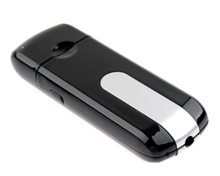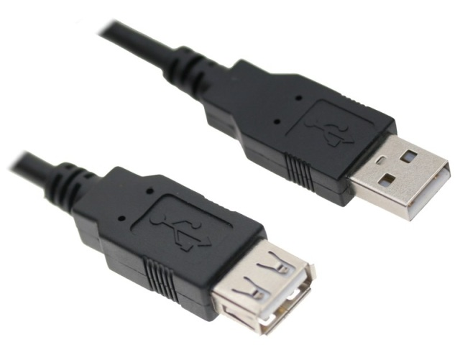

Before You Start
Make sure you have charged the device for 8 or more hours prior to full use.
It is recommended that you charge for 24 hours; however we know this is not always possible.
Turn over for charging instructions…

Overview

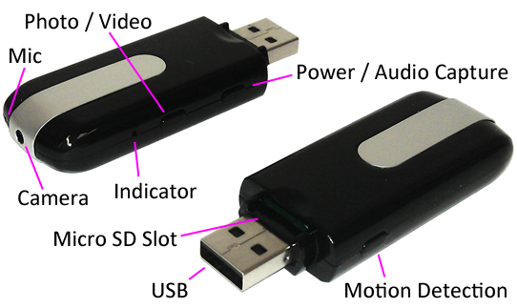
Figure 1
Figure 1 shows the controls that the USB stick uses.

Controls

SD Card Slot (TF)
You are able insert a Micro SD card (TF) up to 32GB into this USB stick.
When holding the USB stick with the Micro SD slot on top, make sure the Micro SD card is facing up so the contact points are facing down (Figure 2).
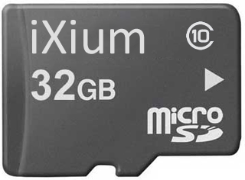
Figure 2

USB: Syncing and Charging
Supplied with the USB stick is a USB cable which enables you to charge the battery and transfer the files that are saved on the Micro SD Card.

Power / Audio Capture

Turn On
Press and hold the Power / Audio Capture button until you can see the indicator has turned red (this should only take 2 or 3 seconds).

Turn Off
Press and hold the Power / Audio Capture button until you can see the indicator goes out (this should only take 2 or 3 seconds).

Audio Capture
Quickly press the Power / Audio Capture button and the indicator will flash blue and then go out. This is now recording audio only.
To stop recording audio quickly press the Power / Audio Capture button again and the indicator light will turn red again. You can turn the USB stick off from here or carry on to use one of the other functions.

Photo / Video
This button enables you to switch between the camera and standard video features depending on what you need.

Camera Mode
Turn the USB Stick on. Once the indicator has turned red then all you need to do is point the USB Stick in the direction you wish to take a picture of and quickly press the Photo / Video button. The Red light will go out momentarily and come back when ready to take the next picture.
When you are done taking pictures you can turn the USB Stick off or use one of the other functions.

Video Mode
Turn the USB Stick on. Once the indicator has turned red press and hold the Photo / Video button and the indicator will then start flashing (this should only take 2 or 3 seconds) and then go out. It is now recording video.
When you are done recording video press and hold the Power / Audio Capture button until you can see the indicator flash blue and then go out (this should only take 2 or 3 seconds). The video has now stopped recording and the USB stick turned off. You can turn the USB stick back on and record another video or plug it into your computer and retrieve the files.
Maximum file size for each recording is 15 minutes.

Motion Detection
Turn the USB Stick on. Quickly press the Motion Detection button and place where you want it to record. It will record in short chunks of video. If there is still motion when one section ends then it will start a new section.
To stop the USB Stick recording quickly press the Motion Detection button and it will stop recording.
You can turn the USB stick off from here or carry on to use one of the other functions.

Timestamp Edit
You may need to update the internal clock for the timestamp shown in images and videos.
To do this, you will need to create a Text file with the date and time.
- Plug the camera into your computer by using a USB cable.
- It will appear as a Removable Disk.
- Open the Removable Disk; you might have a folder called DCIM and a text file called “time” already there.
- If you already have a file called “time” then move onto Step 7.
- Right click in the white space and a menu will appear (Figure 3), move down to “New” and select “Text Document”.

Figure 3
- A new Text document will appear (Figure 4) and give you the option to name it, call it “time”.
Figure 4
- Open this time file and write the date and time in the following method:
2010.01.26 10.10.59 Y (this is example only, use the correct date/time)
2010.01.26 10.10.59 N (Y to display timestamp, N to not display timestamp)
- Save and close the file.
- Unplug the camera from the computer and turn it on. The time is now updated.
- Plug the USB Stick back into your computer and delete the time file if still there.

